Intergenerational Practice

Some practical ideas for intergenerational activities
  - Intergenerational Activities
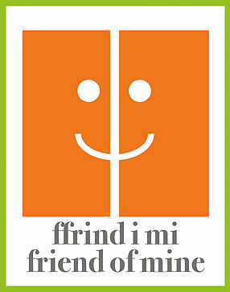

Intergenerational Activity | Anticipated Mutual Benefits | Venue
Arts and Crafts | Well being  Stimulation  Team working skills  Confidence | Care homes, wards, community centres, libraries, sheltered accommodation, schools, colleges
Choir (intergenerational and multigenerational) | Lung health  Well being  Stimulation  Team working skills  Confidence | Care homes, wards, community centres, sheltered accommodation, schools, colleges
Cooking/Sharing Meals | Skill acquisition for children/young people  Sense of purpose for older people | Care homes, wards, community centres, sheltered accommodation, schools, colleges
Dementia Friends Training | Lifelong learning  Dispel myths  Reduce prejudice  Ethically informed citizens  Attitudinal change | Care homes, wards, community centres, sheltered accommodation, schools, colleges
Digital Inclusion | Learning  Sense of purpose  Confidence  Communication skills | Care homes, wards, community centres, sheltered accommodation, schools, colleges
Exercise/Physical Activity | Physical and mental well being  Rehabilitation | Care homes, wards, community centres, sheltered accommodation, schools, colleges
Gardening | Physical and mental well being  Sense of achievement  Learning | Care homes, wards, community centres, sheltered accommodation, schools, colleges
Joint Lobbying | Team working skills  Communication skills  Fulfilment of personal goals | Care homes, wards, community centres, sheltered accommodation, schools, colleges
Performing Arts | Physical and mental well being | Care homes, wards, community centres, sheltered accommodation, schools, colleges
Pimp My Zimmer |  | Care homes, wards, sheltered accommodation
Photography |  | Care homes, wards, community, community centres, sheltered accommodation, schools, colleges
Puzzles and Games | Memory  Cognitive Development  Team work
Mentoring Projects | Older people mentor those at risk:  Sense of worth for older people  Improved skills for children and younger people  Reduce anti-social behaviour  Reduced risk of exclusion  Attitudinal change | Care homes, wards, community centres, sheltered accommodation, schools, colleges
Organising Community Events | Team working skills  Presentation skills  New perspectives  Increased confidence  Sense of worth/satisfaction | Care homes, community centres, sheltered accommodation, schools, colleges
Pen Pals |  | Care homes, community centres, sheltered accommodation, schools, colleges
Reading Clubs |  | Libraries, Care homes, wards, community centres, sheltered accommodation, schools, colleges
Reminiscence and History |  | Libraries, Care homes, wards, community centres, sheltered accommodation, schools, colleges
Residential Home Visits |  | Care Homes, Sheltered Accommodation, Supported Living
Scrap Booking |  | Libraries, Care homes, wards, community centres, sheltered accommodation, schools, colleges
Volunteering | Older people volunteering at child care settings- mentoring new parents  Younger people volunteering in care homes, sheltered accommodation/wards | Care homes, wards, community centres, sheltered accommodation, schools, colleges
Written and Spoken Arts | Creative art clubs/projects | Community venues, care homes, sheltered accommodation, supported living

