Intergenerational Befriending in Care Homes

After attending the Ffrind i mi/Friend of mine engagement event in May 2016, Arleen Testa, manager of Glan Yr Avon Care Home, Fleur De Lys decided to approach local secondary and nursery schools to ask if they would allow the children to attend the home. The aim was for school and preschool children to visit the older people living in the home and support intergenerational befriending.

During a particular visit, a 3 year old nursery school child approached Arleen and asked ‘Why can’t Frank talk? Arleen explained that Frank couldn’t talk with words like she could, but could talk through laughing. The little girl smiled and walked straight back to Frank.
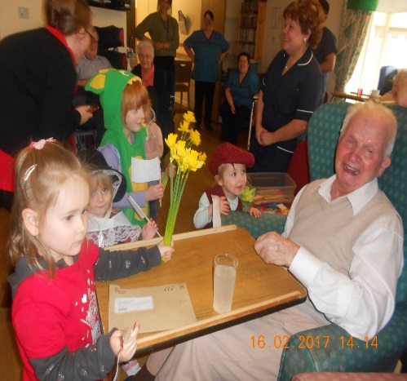
She looked at Frank and started to talk……………. “hahahahahahahaha?” and Frank replied “hahahahahahahaha”.

They held this conversation for over 30 minutes. The smiles on both the child’s and Frank’s faces expressed the sheer joy they both felt at being able to communicate with each other.

She still visits Frank today.

